273 Research Paper

Research paper Presentation

1. Shivani Parate
   * Byzantine Generals Problem
   * Byzantine Fault tolerance
   * Introduction to PBFT
2. Aditya Bhole
   * 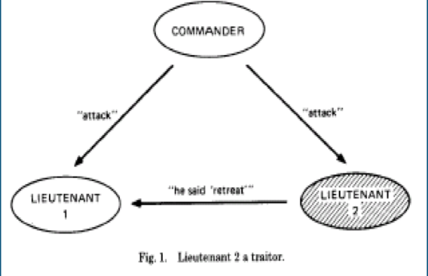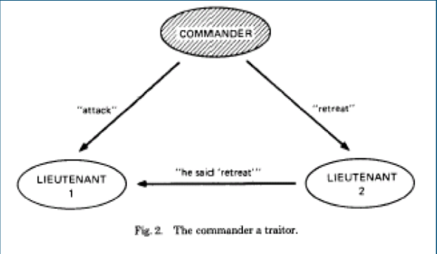
   * Explanation of proof : 3f +1 minimum number of replicas to be present in the system
   * Safety and Liveness properties
3. Rikitha Manjunath
   * Algorithm description covering state machine replication and views
   * Working of algorithm
   * Details abt Client side

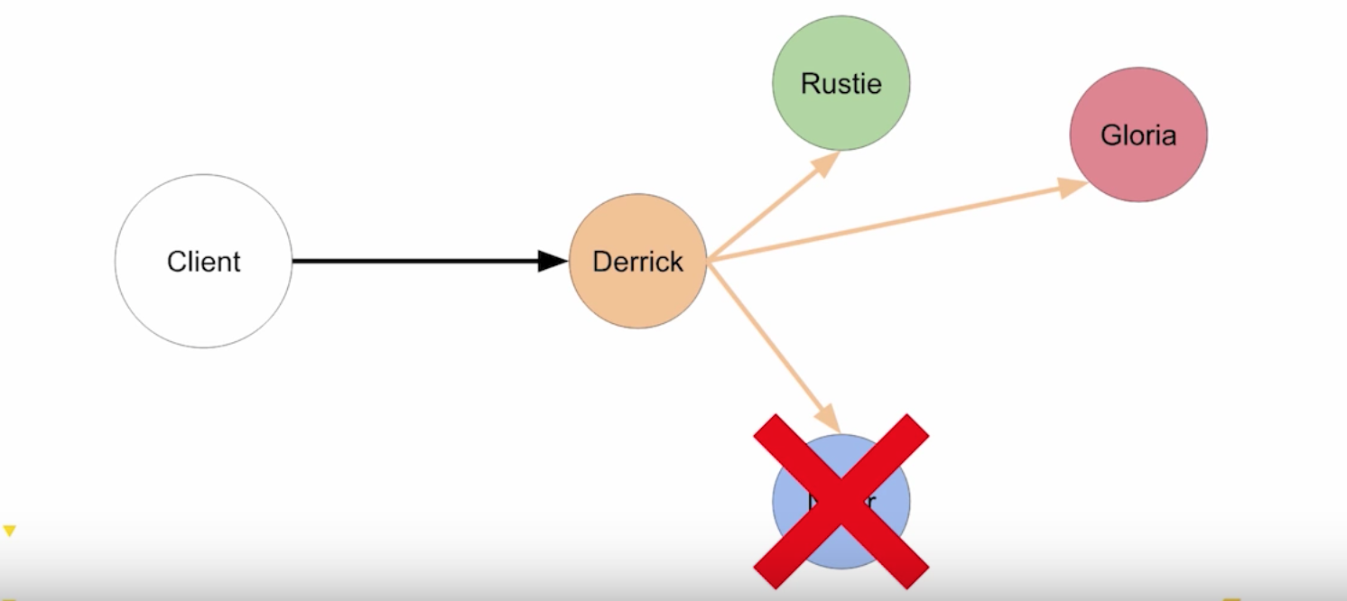

1. [Rajat Dineshchandra Chaurasia](https://sjsu.instructure.com/courses/1265407/users/4374023)
   * Normal case operation
   * 3 phase protocol : PrePrepare , Prepare, Commit

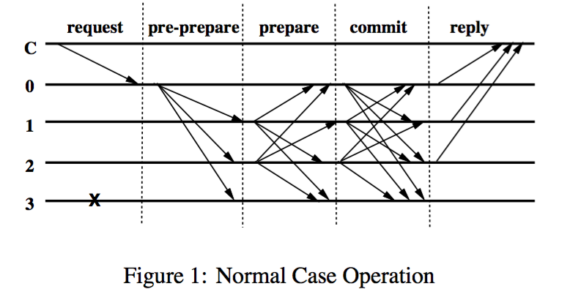

1. Shraddha Kabade
   * Applications of PBFT
   * Demo of the working code
   * Github Link : <https://github.com/bigpicturelabs/consensusPBFT>

`

Working screenshot

